Top 5 Jungle Champions for Beginners in League of Legends
The article focuses on the top five jungle champions for beginners in League of Legends: Amumu, Master Yi, Rammus, Warwick, Sejuani. It highlights the importance of selecting beginner-friendly champions that simplify gameplay mechanics and enhance the learning curve, emphasizing characteristics such as strong early-game presence, crowd control, and versatility. The article also discusses how these champions can help new players develop essential skills like map awareness and objective control, ultimately improving their overall performance in the game. Additionally, it provides insights into effective jungle pathing, communication strategies, and common mistakes to avoid, offering a comprehensive guide for beginners looking to succeed in the jungle role.
What are the Top 5 Jungle Champions for Beginners in League of Legends?

Understanding the Jungle Role in Season 15
Versatility is crucial when choosing jungle champions for beginners because it allows players to adapt to various game situations and team compositions. Champions with versatile abilities can fulfill multiple roles, such as damage dealing, crowd control, or tanking, which is essential for new players still learning the game dynamics. For instance, champions like Amumu and Warwick can engage in fights, provide utility, and sustain themselves, making them effective in diverse scenarios. This adaptability helps beginners understand different aspects of gameplay, such as ganking, objective control, and team fighting, ultimately enhancing their learning experience and overall performance in the game.

What Makes Jungle Challenging for Newcomers
Jungling in League of Legends can be one of the most challenging roles for newcomers due to its unique responsibilities and complex gameplay. Here are some key reasons why the jungle role often feels overwhelming for new players:
- Map Awareness and Decision-Making
Junglers are responsible for understanding the state of the game across the entire map. This includes monitoring enemy movements, recognizing gank opportunities, and responding to objectives like Dragon or Baron. For newcomers, balancing these tasks while farming jungle camps can be daunting.
- Lack of map awareness often leads to missed opportunities or poor positioning.
- Decision-making, such as when to gank or prioritize farming, is difficult without experience.
- Jungle Pathing Knowledge
Each champion has optimal jungle routes based on their abilities, clear speed, and health sustain. Learning these routes and adapting to the game's flow—like when camps are contested or cleared early—requires practice and game knowledge.
- Inefficient pathing can leave junglers under-leveled or low on health.
- Mismanagement of Smite usage can result in losing jungle camps or objectives.
- Understanding Lane Dynamics
New junglers often struggle to evaluate when and where to gank effectively. They must understand lane matchups, wave states, and enemy summoner spell cooldowns to decide the right moment to engage.
- Ganking at the wrong time can waste time or give the enemy an advantage.
- Failing to recognize overextended allies or enemies can lead to unsuccessful ganks.
- Objective Control
Junglers are often expected to control neutral objectives, like Dragons, Rift Heralds, and Baron Nashor. Coordinating with teammates to secure these objectives can be challenging, especially when facing experienced opponents.
- Poor Smite timing can cost critical objectives.
- Lack of vision control can make objectives risky to contest.
- High Pressure and Blame
The jungle role is often the target of blame when things go wrong, such as lost objectives, failed ganks, or snowballing enemies. This pressure can discourage new players from sticking with the role.
- Feeling responsible for the entire team's success can be overwhelming.
- Toxicity from teammates can impact confidence and learning.
- Champion Pool Mastery
Jungle champions vary widely in playstyle, from farming-focused junglers like Master Yi to gank-heavy ones like Lee Sin. Learning to adapt playstyles and selecting the right champion for the situation takes time.
- Limited knowledge of jungle champion mechanics or matchups.
- Inability to adapt to team compositions or game states.

Tips for New Jungle Players
- Focus on a Small Champion Pool: Start with beginner-friendly junglers like Warwick, Amumu, or Rammus to build confidence.
- Learn Optimal Pathing: Practice basic jungle routes in custom games before queuing up.
- Communicate with Your Team: Let teammates know your plans and ask for help securing objectives.
- Prioritize Vision: Use Control Wards and sweepers to secure critical areas of the map.
- Stay Positive: Mistakes are part of learning. Focus on improving game by game.
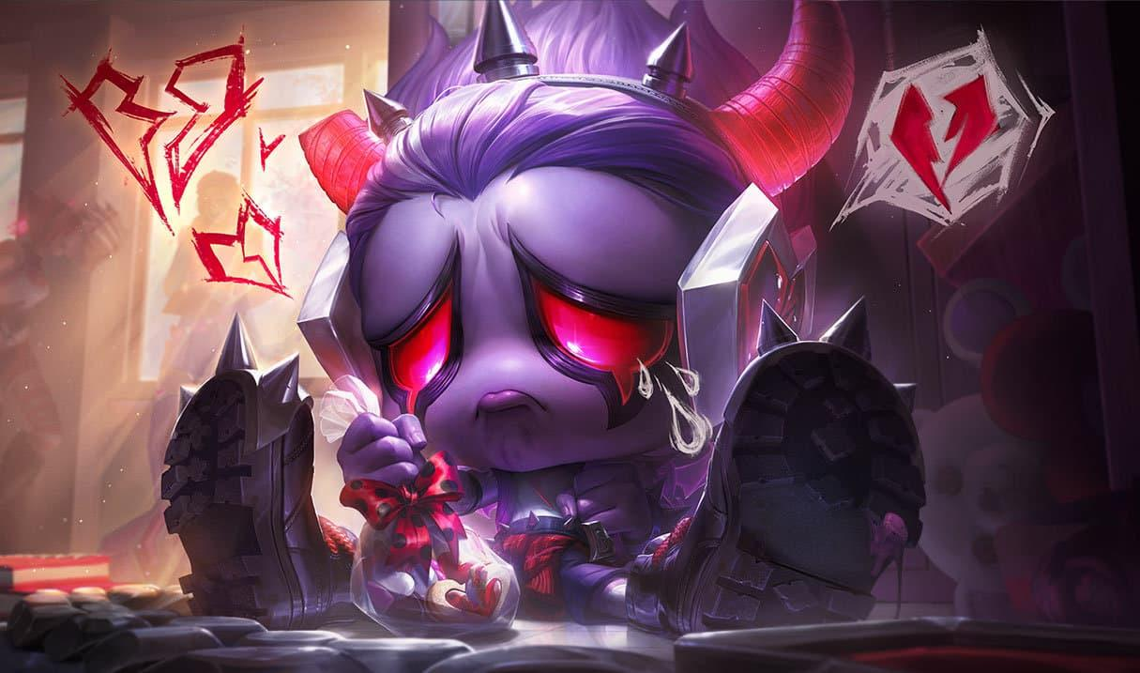

Amumu - the Sad Mummy
Amumu is a very easy Jungler to learn. Firstly, he has AOE abilities that help him clear the jungle. Secondly, he has 2 Q abilities which means he has two chances of landing his Q on an enemy.
Amumu’s Ultimate is also powerful. It has a large radius and can CC multiple enemies. You don’t even have to hit an enemy champion to close the gap as your Q is versatile and can allow you to gain distance and then Ult them.
See more: Amumu Jungle Build Guides, Runes, Items, and Abilities


Master Yi - the Wuju Bladesman
Master Yi is one of the strongest low ELO Junglers. He is straightforward to play as he has no skill shots, and the only hard thing about him is using his Q to dodge incoming damage and skill shots. A good Master Yi will time their Q, so they dodge damage, which is one of the hardest things about him.
Master Yi is also someone that can snowball very quickly if he gets a few kills, which makes him great for carrying in solo queue.
See More:
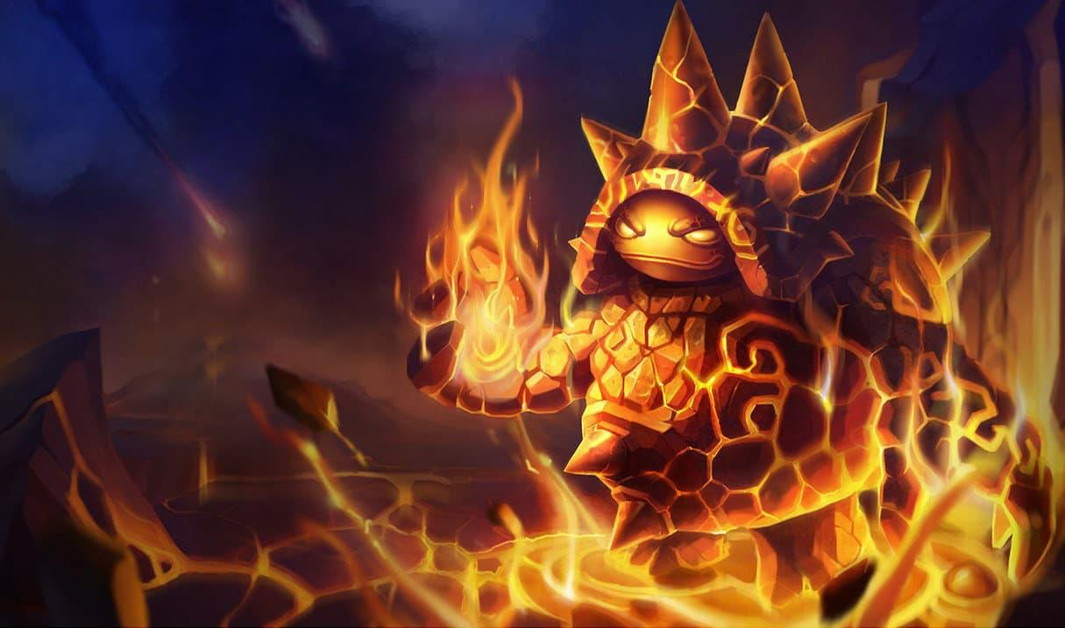

Rammus - the Armordillo
Rammus is a tank champion with point and click abilities. Additionally, his Ultimate, which is his only real “skill shot”, has a large area of effect, which is relatively easy to land too. Rammus is an excellent pick into teams with a lot of AD, making games a lot easier as he can stack armour rather than build mixed defensive items.
Sonic the Hedgehog is very easy to gank with too. He just needs to roll up with his Q, dodge minions and hit the enemy with his Q before taunting them. Alternatively, he can use his Ultimate to jump over minions to get onto the target as well.
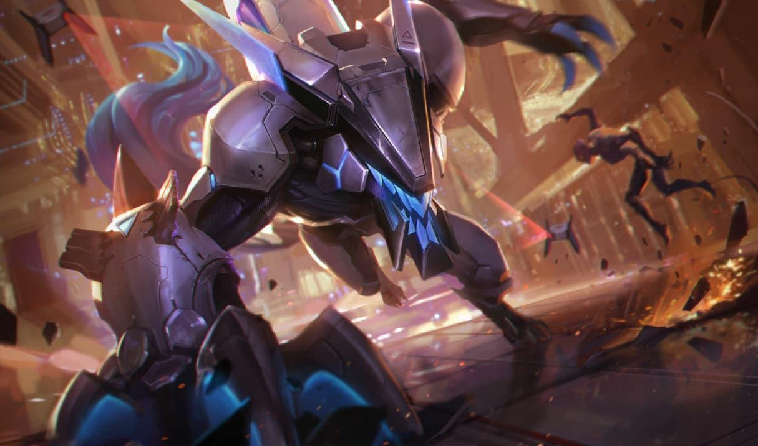

Warwick
Warwick is similar to other champions on our list, such as Master Yi as both can quickly snowball and take over the game if they get kills early.
Warwick has a very healthy clear thanks to his Q. As well as that, Warwick tends to build items that keep him alive in team fights. This combined, offer the Warwick a lot of survivability.
Finally, Warwicks Ultimate is a great picking tool that can be used to almost guarantee kills. All you need to do is rock up to a lane and use it on the enemy.
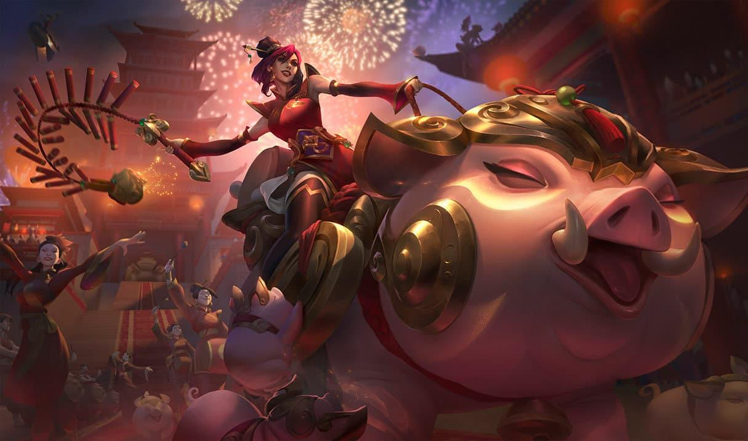

Sejuani - Fury of the North
Sejuani is a very good Jungler for beginners because she is tanky and has a lot of survivability. Her clears are pretty simple and rather healthy, which makes learning the jungle pretty good.
Post 6, her Ultimate is powerful and is easy to land. It can be the difference between a victory or defeat, though, so something to keep in mind is that your Ultimate is a great tool to get kills. Make sure you try and gank your allies whenever it is up for free kills.

What Makes Jungle Challenging for Newcomers
Jungling in League of Legends can be one of the most challenging roles for newcomers due to its unique responsibilities and complex gameplay. Here are some key reasons why the jungle role often feels overwhelming for new players:
- Map Awareness and Decision-Making
Junglers are responsible for understanding the state of the game across the entire map. This includes monitoring enemy movements, recognizing gank opportunities, and responding to objectives like Dragon or Baron. For newcomers, balancing these tasks while farming jungle camps can be daunting.
- Lack of map awareness often leads to missed opportunities or poor positioning.
- Decision-making, such as when to gank or prioritize farming, is difficult without experience.
- Jungle Pathing Knowledge
Each champion has optimal jungle routes based on their abilities, clear speed, and health sustain. Learning these routes and adapting to the game's flow—like when camps are contested or cleared early—requires practice and game knowledge.
- Inefficient pathing can leave junglers under-leveled or low on health.
- Mismanagement of Smite usage can result in losing jungle camps or objectives.
- Understanding Lane Dynamics
New junglers often struggle to evaluate when and where to gank effectively. They must understand lane matchups, wave states, and enemy summoner spell cooldowns to decide the right moment to engage.
- Ganking at the wrong time can waste time or give the enemy an advantage.
- Failing to recognize overextended allies or enemies can lead to unsuccessful ganks.
- Objective Control
Junglers are often expected to control neutral objectives, like Dragons, Rift Heralds, and Baron Nashor. Coordinating with teammates to secure these objectives can be challenging, especially when facing experienced opponents.
- Poor Smite timing can cost critical objectives.
- Lack of vision control can make objectives risky to contest.
- High Pressure and Blame
The jungle role is often the target of blame when things go wrong, such as lost objectives, failed ganks, or snowballing enemies. This pressure can discourage new players from sticking with the role.
- Feeling responsible for the entire team's success can be overwhelming.
- Toxicity from teammates can impact confidence and learning.
- Champion Pool Mastery
Jungle champions vary widely in playstyle, from farming-focused junglers like Master Yi to gank-heavy ones like Lee Sin. Learning to adapt playstyles and selecting the right champion for the situation takes time.
- Limited knowledge of jungle champion mechanics or matchups.
- Inability to adapt to team compositions or game states.

Key Skills Required for Jungle Success
Success in the jungle role in League of Legends requires mastering a unique set of skills. These go beyond basic gameplay mechanics and focus on macro decision-making, adaptability, and efficient resource management. Here's a breakdown of the key skills needed to excel as a jungler:
- Map Awareness
Junglers must maintain constant awareness of the minimap to track enemy movements, monitor lane states, and identify opportunities to influence the game.
- Helps you anticipate enemy jungler movements and avoid being counter-jungled.
- Allows you to plan ganks, secure objectives, and respond to teammate needs.
- Frequently glance at the minimap, especially after clearing a camp or during downtime.
- Use wards to track high-priority areas like enemy camps or objectives.
- Efficient Jungle Pathing
A strong understanding of jungle routes ensures you maximize experience and gold while maintaining pressure on the map.
- Keeps you ahead in levels and gold compared to laners and the opposing jungler.
- Allows you to be in the right place at the right time for ganks or objectives.
- Learn optimal pathing for your champion (e.g., full clears for farming junglers, early ganks for aggressive junglers).
- Adapt routes based on game flow, such as prioritizing contested camps or responding to invading enemies.
- Decision-Making Under Pressure
Junglers must make split-second decisions, such as choosing between farming, ganking, or contesting objectives.
- Poor decisions can lead to falling behind or giving enemies unnecessary advantages.
- Effective decision-making keeps your team ahead and denies the enemy team opportunities.
- Analyze the risk vs. reward of every action (e.g., is it safe to invade? Can I secure a kill with this gank?).
- Watch replays to identify missed opportunities or better decision-making paths.
- Ganking and Pressure Application
Ganking effectively requires timing, understanding of lane matchups, and positioning.
- Successful ganks help snowball your lanes and put pressure on the enemy team.
- Even the threat of a gank can force opponents to play cautiously.
- Pay attention to lane positioning (e.g., overextended enemies, low-health targets).
- Communicate with teammates and track enemy summoner spell cooldowns.
- Objective Control
Controlling neutral objectives like Dragons, Rift Heralds, and Baron Nashor is a critical jungler responsibility.
- Securing objectives provides significant buffs that can swing the game in your team’s favor.
- Denying objectives to the enemy prevents them from gaining an edge.
- Always carry a Control Ward to secure vision around objectives.
- Time your Smite usage effectively by practicing last-hitting jungle camps in custom games.
- Tracking the Enemy Jungler
Predicting the enemy jungler’s movements allows you to counter their plays, secure
- your own jungle, and avoid dangerous situations.
- Helps you deny resources and gain an advantage.
- Prevents your teammates from being caught off-guard by enemy ganks.
- Note where the enemy jungler starts based on lane leash behavior.
- Use vision tools and team pings to track their likely pathing.
- Adaptability.
Junglers must adapt their playstyle to the flow of the game, changing priorities as the situation evolves.
- A rigid strategy can fail against unexpected enemy plays or team dynamics.
- Flexibility helps you maximize your impact in every stage of the game.
- Stay open to altering your build, pathing, or role based on your team’s needs.
- Pay attention to game tempo, such as snowballing lanes or countering a fed enemy.
- Communication and Leadership
As the jungler, you often dictate the pace of the game. Effective communication with your team is essential for success.
- Ensures teammates are ready for ganks, objectives, or invades.
- Builds trust and coordination within the team.
- Use pings to signal intentions clearly (e.g., danger, missing enemies, or target focus).
- Provide information about enemy jungle location or summoner spell cooldowns.
- Mental Resilience
Jungling comes with significant pressure, and mistakes are inevitable. Maintaining a strong mindset helps you stay focused and improve over time.
- Avoids tilting after setbacks like losing objectives or failed ganks.
- Keeps you playing optimally throughout the match.
- Focus on what you can control, rather than blaming teammates or external factors.
- Treat every game as a learning experience to refine your skills.

Conclusion
The Jungle role is the least forgiving role in the game. I would highly recommend playing easier champions if you’re learning the role. Once you’ve mastered these champions, move on to harder champions to further extend your jungle knowledge.

